**CHAPTER - 3**

**SYSTEM DESIGN**

**3.1 EXISTING SYSTEM:**

The application provides the live location of the bus to the user. The commuters can not only fetch the bus location but also know estimate time taken by bus to reach its destination. The Location information is fetched from the online database which receives the data regarding the location from a separate application used by drivers/conductors on the bus. This helps in maintaining the uniqueness of the bus while displaying its location on the map. The request made by the client for the bus information will be fetched from the database and delivered to client through server. The driver/conductor will send its coordinates continuously to our server where data will be stored. When the user selects that particular Bus ID, its location will be retrieved from the server and shown on the map. Since the coordinates will be changing, the point on the map will keep on moving, hence the user can actually see the live location of the selected bus.

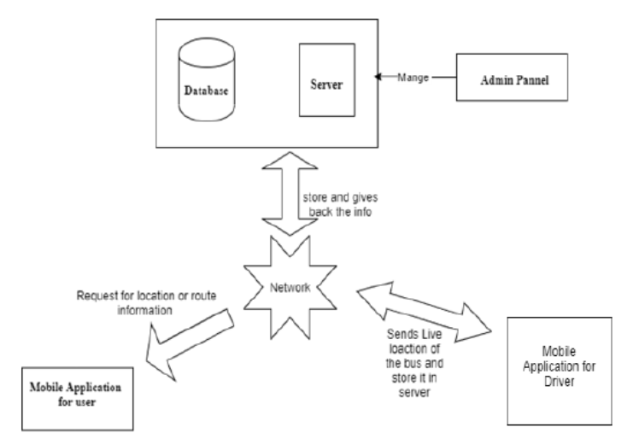

Fig 3.1.1

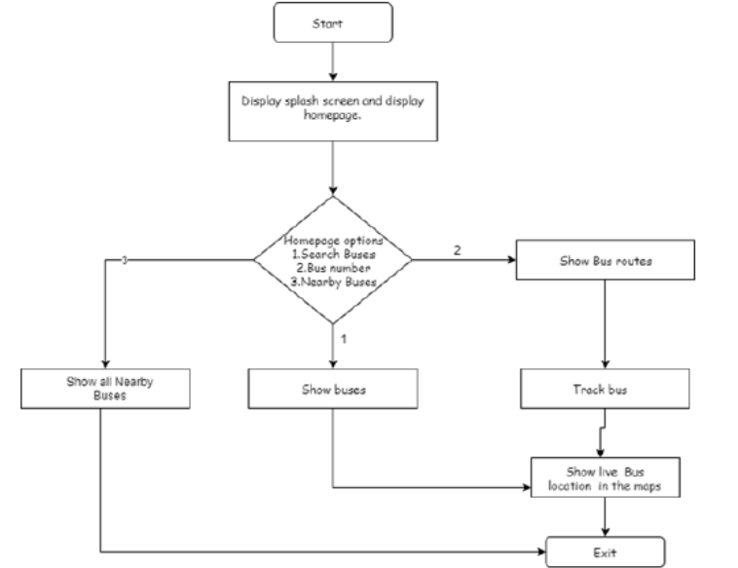

Fig 3.1.2

**3.2Disadvantages:**

While the system outlined offers significant benefits in terms of real-time tracking of bus locations for commuters, there are also some potential drawbacks to consider. Firstly, reliance on continuous data transmission from the bus to the server may pose challenges in areas with poor network connectivity, leading to inaccurate or delayed location updates. Additionally, the need for a separate application used by drivers or conductors introduces complexity and potential issues with user adoption and training. Moreover, the dependency on online databases and servers means that any technical glitches or server downtime could disrupt the service, leaving commuters without access to vital information about bus locations and estimated arrival times. Lastly, there are concerns regarding privacy and data security, as the continuous sharing of location data raises questions about who has access to this information and how it is being used and protected. Therefore, while the live tracking system offers enhanced convenience and transparency for commuters, careful consideration of these potential disadvantages is necessary to ensure its effectiveness and reliability in practical implementation.

**3.4 Proposed solution:**

Phase One of our proposed solution involves the development and implementation of a website dedicated to providing essential bus information. This initial phase focuses on laying the groundwork for enhancing public transportation efficiency. The website will serve as a central hub for bus-related information, offering users access to bus schedules, route details, and estimated arrival times. While real-time GPS tracking will not be available in this phase, users will still benefit from up-to-date schedule information and route planning capabilities. Passengers visiting the website will be able to plan their journeys more effectively, reducing wait times and improving overall trip satisfaction. Additionally, basic data analytics tools will be provided to bus operators, allowing them to analyse schedule performance and identify potential areas for improvement. Phase Two will introduce a dedicated mobile application, building upon the foundation established in Phase One. With the launch of the app, passengers will gain access to advanced features such as real-time bus tracking, personalized notifications, and seamless integration with other modes of transportation. Furthermore, the app will offer enhanced data analytics tools for bus operators, enabling them to optimize schedules, allocate resources efficiently, and deliver a more responsive and reliable service to passengers. By adopting this phased approach, we aim to gradually introduce improvements to the public transportation system, starting with basic information provision and gradually expanding to include more advanced features. Ultimately, our goal is to enhance the passenger experience, increase ridership rates, and promote the widespread adoption of public transportation as a sustainable and convenient mode of travel.

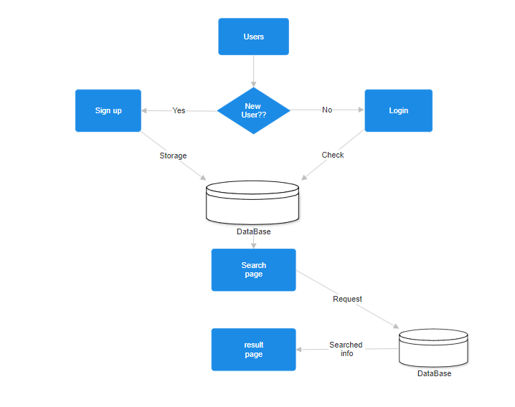**3.4.1 Proposed solution Architecture:**